**RTS RADIO MODULE**

**

**ACCESSSORY**





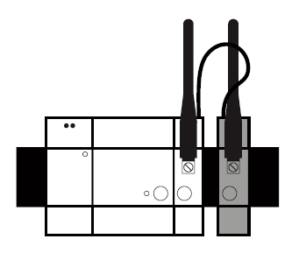

The Somfy DIN Rail RTS Radio Module is a component of the Somfy DIN Rail solution.

It is used to connect, control and program compatible RTS radio devices.

CONTENT

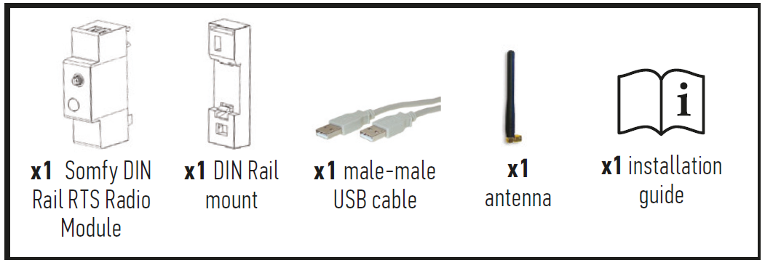

PRODUCT DESCRIPTION

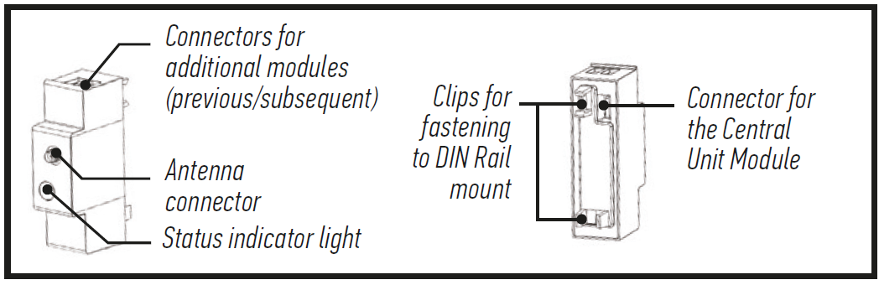

IMPORTANT

**Equipment connected to 230 V power supply.**

Do not connect any load to the available USB ports.

**Radio equipment.**

• A maximum of four Radio Modules can be connected to the Somfy DIN Rail solution.

• Metal enclosure or cabinet with metal door:

- The Radio Module might not operate correctly (radio interference).

- In this case, replace the antenna supplied with a Somfy remote antenna(available separately) and attach it outside the cabinet.

**Prerequisites**

• Enclosure equipped with a TS-35/7.5 or TS-35/15 DIN Rail.

• The other Somfy DIN Rail modules required: Power Supply Unit and Central Unit.

• Installation must be carried out by a professional.

TECHNICAL SPECIFICATIONS

|  |  |
| --- | --- |
| **Radio protocol** | RTS |
| **Frequency bands and Maximum power used** | 433.05 MHz - 434.79 MHz/ erp < 10 mW |
| **Power consumption during normal operation** | 5 V continuous 500 mA (0.5 A) |
| **Impact rating resistance** | IK07 - IP |
| **Operating temperature** | -10°C to +40°C |
| **Maximum operating altitude** | 2 000 m |
| **Pollution category** | Category 2 |
| **Operating humidity** | 5 % to 90 % |
| **Dimensions *(l x w x h)*** | 27 x 90 x 58 mm |
| **Plastic casing** | PC V0 |







