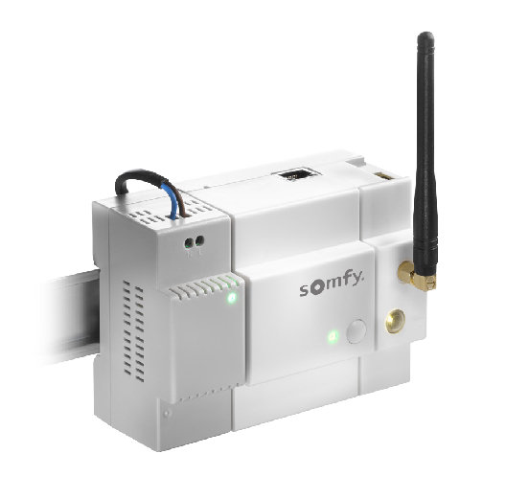

|  |  |
| --- | --- |
| **INSTALLER** | **DESIGNED FOR PROFESSIONALS**  Solution to be installed in the electrical panel |
| MODULAR |  |
| EASY TO INSTALL |  |
| **END-USER** | **SMART-HOME READY HOUSING**  All the benefits of TaHoma Smart-Home solution  natively integrated in housing |
| CONNECT YOUR HOME |  |
| IT’S EASY |  |



 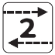

**SMART-HOME GATEWAY FOR ELECTRICAL PANEL**

*The dedicated solution for Connected New housing*





**PREFERED INSTALLATION METHOD**

|  |  |
| --- | --- |
| **INSTALLER** | 1/ INSTALL MODULES in electrical panel  2/ DOWNLOAD Somfy DIN-Rail app  3/ PAIR EQUIPMENT to TaHoma DIN-Rail |
| ***Offline* installation**  *= Mobile application*  *No login needed* | For 2/  Use Installer application = Somfy DIN-Rail  + Additional WiFi router required  = WiFi local direct link: Smartphone < > TaHoma DIN-Rail |
| **END-USER** | 1/ GO TO: **tahoma-din.somfy.com**  2/ FOLLOW INSTRUCTIONS (create account/activate box)  3/ DOWNLOAD TAHOMA APP  + CONFIGURE INTERNET CONNECTION of TaHoma DIN-Rail  = Enjoy Smart Home  with equipement of housing already installed in TaHoma |

**ALTERNATE INSTALLATION METHOD**

|  |  |
| --- | --- |
| **INSTALLER** | 1/ INSTALL MODULES in electrical panel  2/ CONNECT FOR SETUP  3/ PAIR EQUIPMENT to TaHoma DIN-Rail |
| ***Online* installation**  *= Web Browsers*  *SomfyPRO website*  *REQUIRES*  *a SomfyPRO account* | For 2/  Go to SomfyPRO website (from computer/tablet)  + Additional 3G/4G router required  = Online setup: SomfyPRO < > TaHoma DIN-Rail |
| **END-USER** | 1/ GO TO: **tahoma-din.somfy.com**  2/ FOLLOW INSTRUCTIONS (create account/activate box)  3/ DOWNLOAD TAHOMA APP  + CONFIGURE INTERNET CONNECTION of TaHoma DIN-Rail  = Enjoy Smart Home  with equipement of housing already installed in TaHoma |

 



**INSTALLATION**



Enocean

Zwave

Enocean

+

+

+





























+

+

+



 





OTHERS

SECURITY

MUSIC

LIGHTING

HEATING

DOORS & WINDOWS

VENTILATION

|  |  |  |  |  |
| --- | --- | --- | --- | --- |
| **INSTALLER** |  | | | |
| **Offline installation**  *= Mobile application* |  | | https://images.indiegogo.com/file_attachments/1082509/files/20141208220600-iphone-android-logos.gif?1418105160 | |
| **Online installation**  *= Web Browsers*  *(SomfyPro website)* |  | | | |
| **END-USER** |  | | | |
| **Mobile application** | Afficher l'image d'origine | | https://images.indiegogo.com/file_attachments/1082509/files/20141208220600-iphone-android-logos.gif?1418105160 | |
| **Web Browsers** |  | | | |
| **PROTOCOLS** | Included in pack  http://www.norden24.pl/data/Image/artykuly/io-homecontrol.gif | | With additional module  http://www.somfy-architecture.com/buildings/common/img/library/logo_RTS.jpg | |
| **PARTNERS** | Included in pack  See below: | With additional module  See below: | | Not possible  See below: |

**COMPATIBILITIES**





**PACK CONTENT**

* Power Supply Unit
* Central Unit
* Radio Module - io

included in Central Unit

Also includes

x1 Antenna for Radio Module - io (868MHz = medium length)

x1 Additional USB cable for connection of other radio modules to gateway (long length)

x1 Ethernet cable

Sticker for Ethernet connection

Quickstart for installation

Individual Installation guide for each module

 









 



**PACK CONTENT > DETAILS**

**1/ POWER SUPPLY UNIT *for TaHoma DIN-Rail***

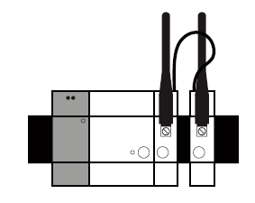

The Somfy DIN Rail Power Supply Module is a required component of the Somfy DIN Rail

Solution.

It is used to power the solution (Central Processing Unit module, compatible Radio Units,…).

RELATED CONTENT

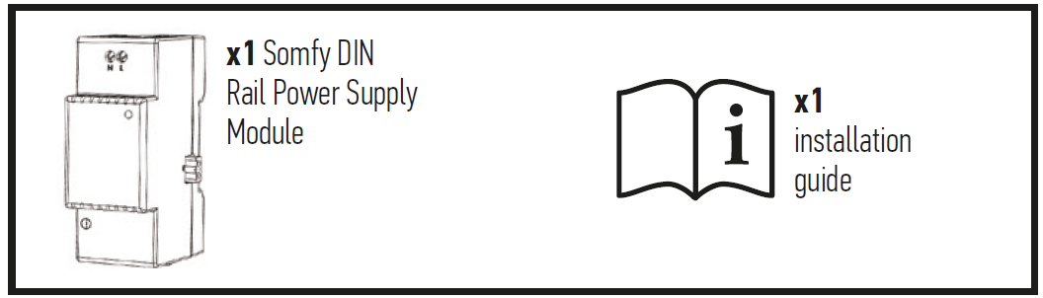

PRODUCT DESCRIPTION

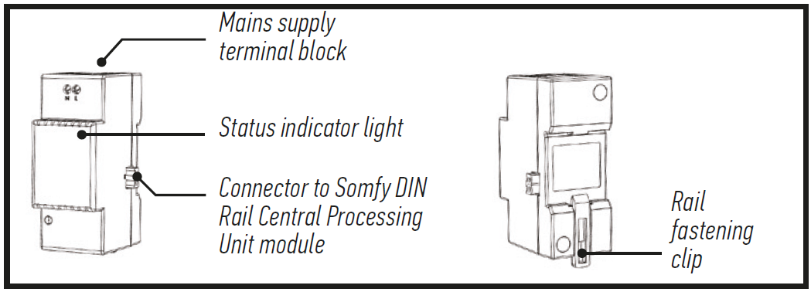

IMPORTANT

**Equipment connected to 230 V power supply.**

• The module must be installed and removed with the power supply switched off.

• We strongly recommend that you add a dedicated circuit breaker module (2 A) to manage

the Somfy DIN Rail solution (upstream of this power supply module).

**Prerequisites**

• Enclosure equipped with a TS-35/7.5 or TS-35/15 DIN Rail.

• The other Somfy DIN Rail modules required: Central Processing Unit module and at least one Radio Unit (maximum of four).

• Installation on a concrete surface or any other non-flammable surface.

• Installation must be carried out by a professional.

TECHNICAL SPECIFICATIONS

|  |  |
| --- | --- |
| **Input power supply** | 100 – 240 V ~ 50 / 60 Hz |
| **Power consumption during normal operation** | 0.26 A |
| **Output power supply** | 5 V continuous 1.8 A |
| **Appliance class** | Class II |
| **Impact rating resistance** | IK07 |
| **Operating temperature** | -10°C to +40°C |
| **Maximum operating altitude** | 2 000 m |
| **Pollution category** | Category 2 |
| **Operating humidity** | 5 % to 90 % |
| **Dimensions *(l x w x h)*** | 90 x 36 x 58 mm |
| **Plastic casing** | PC V0 |





 



**PACK CONTENT > DETAILS**

**2/ CENTRAL UNIT *for TaHoma DIN-Rail***

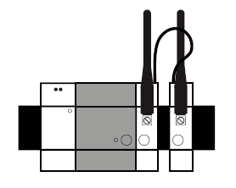

The Somfy DIN Rail Central Unit module is a required component of the Somfy DIN Rail

Solution.

It is the heart of the system and is used to connect other compatible modules (radio, etc.).

RELATED CONTENT

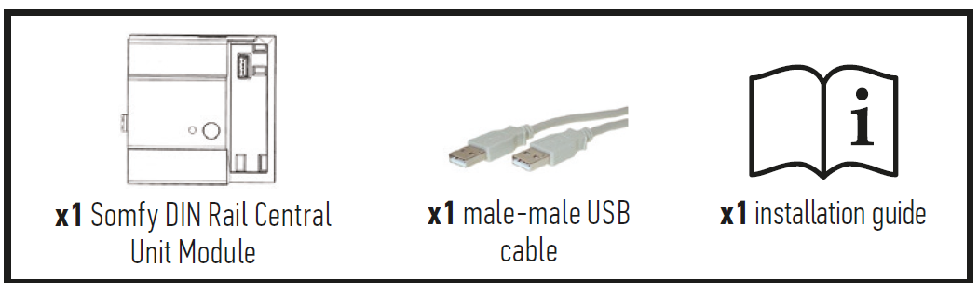

PRODUCT DESCRIPTION

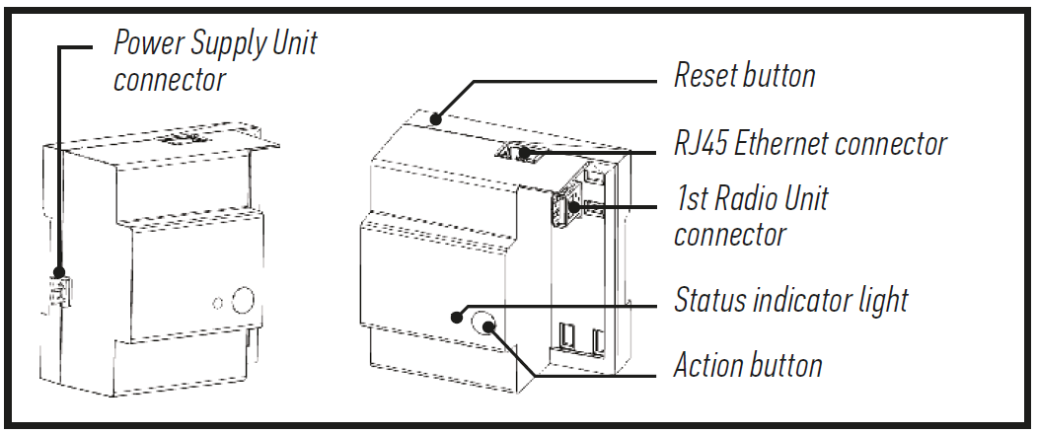

IMPORTANT

**Equipment connected to 230 V power supply.**

The module must be installed and removed with the power supply switched off.

• Do not use a Power over Ethernet (POE) cable.

• Do not connect any load to the available USB port.

**Prerequisites**

Enclosure equipped with a TS-35/7.5 or TS-35/15 DIN Rail.

• The other Somfy DIN Rail modules required: power supply module and at least one Radio Unit (maximum of four).

• Installation must be carried out by a professional.

TECHNICAL SPECIFICATIONS

|  |  |
| --- | --- |
| **Power consumption during normal operation** | 5 V continuous 500 mA (0.5 A) |
| **Impact resistance rating** | IK07 |
| **Operating temperature** | -10°C to +40°C |
| **Maximum operating altitude** | 2 000 m |
| **Pollution category** | Category 2 |
| **Operating humidity** | 5 % to 90 % |
| **Dimensions *(l x w x h)*** | 89.5 x 90 x 58 mm |
| **Plastic casing** | PC V0 |





 



**PACK CONTENT > DETAILS**

**3/ io RADIO MODULE *for TaHoma DIN-Rail***



The Somfy DIN Rail io Radio Module is a component of the Somfy DIN Rail solution.

It is used to connect, control and program compatible io-homecontrol® radio devices.

RELATED CONTENT

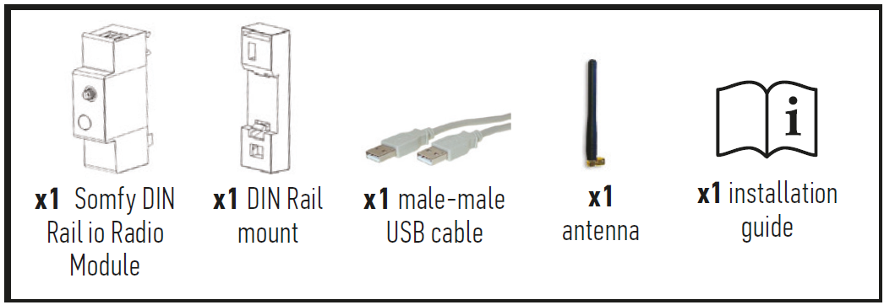

PRODUCT DESCRIPTION

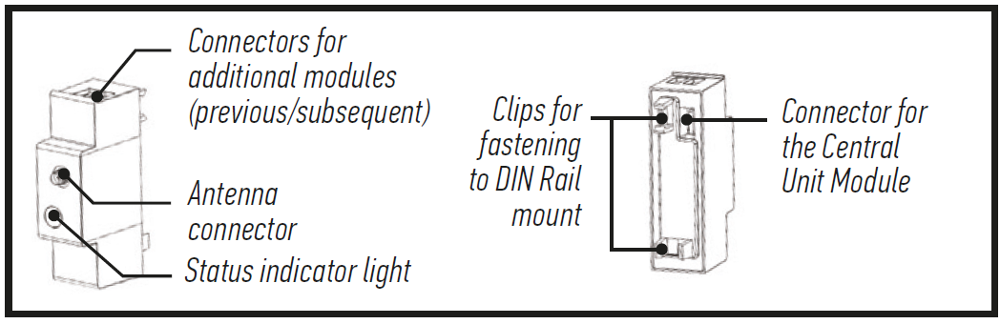

IMPORTANT

**Equipment connected to 230 V power supply.**

Do not connect any load to the available USB ports.

**Radio equipment.**

• A maximum of four Radio Modules can be connected to the Somfy DIN Rail solution.

• Metal enclosure or cabinet with metal door:

- The Radio Module might not operate correctly (radio interference).

- In this case, replace the antenna supplied with a Somfy remote antenna(available separately) and attach it outside the cabinet.

**Prerequisites**

• Enclosure equipped with a TS-35/7.5 or TS-35/15 DIN Rail.

• The other Somfy DIN Rail modules required: Power Supply Unit and Central Unit.

• Installation must be carried out by a professional.

TECHNICAL SPECIFICATIONS

|  |  |
| --- | --- |
| **Radio protocol** | http://www.norden24.pl/data/Image/artykuly/io-homecontrol.gif io-homecontrol |
| **Frequency bands and Maximum power used** | 868.000 MHz - 868.600 MHz - ERP <25 mW  868.700 MHz - 869.200 MHz - ERP <25 mW  869.700 MHz - 870.000 MHz - ERP <25 mW |
| **Power consumption during normal operation** | 5 V continuous 500 mA (0.5 A) |
| **Impact rating resistance** | IK07 - IP |
| **Operating temperature** | -10°C to +40°C |
| **Maximum operating altitude** | 2 000 m |
| **Pollution category** | Category 2 |
| **Operating humidity** | 5 % to 90 % |
| **Dimensions *(l x w x h)*** | 27 x 90 x 58 mm |
| **Plastic casing** | PC V0 |

 



 

*\*More equipment possible but not guaranteed.*



**TAHOMA FEATURES**

FUNCTIONAL SPECIFICATIONS

|  |  |
| --- | --- |
| **Max equipment (all protocols) : 200\*** | |
| **Equipment** | **Max** |
| ***Included*** | |
| IO / OVP equipment | 200 |
| Scenario players | 20 |
| ***IP gateways & Cloud-to-Cloud compatibility*** | 20 |
| ***Including (non-exhaustive list):*** |  |
| HUE Bridge | 1 (50 lamps) |
| Number of Somfy Protect accounts (number of devices depends on Somfy Protect limitations) | 1 |
| Number of Connected Doorlock accounts (number of devices depends on Somfy Connected Doorlock limitations) | 1 |
| Number of Connected Thermostat accounts (number of devices depends on Somfy Connected Doorlock limitations) | 1 |
| Visidom cameras | 8 |
| ***With additional Modules*** | |
| RTS equipment | 50 |
| EnOcean equipment | 50 |
| Zwave equipment | 60 |
| **Functions** | **Max** |
| Scenario | 40 |
| Day | 40 |
| SMART | 20 |
| **Others** | **Max** |
| Condition in a SMART | 6 |
| E-mail alerts | 3 |
| SMS alerts (paid option, availability depending on countries) | 3 |
| Push alerts | 20 |

